**Assignment No. 2**

2. Installation and configure Google App Engine.

Soln :

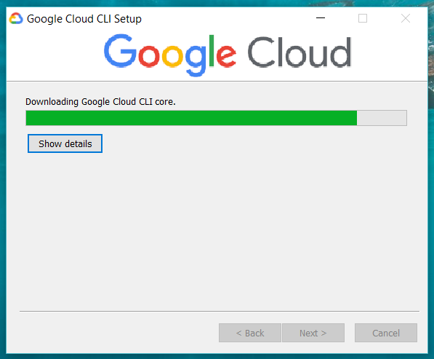

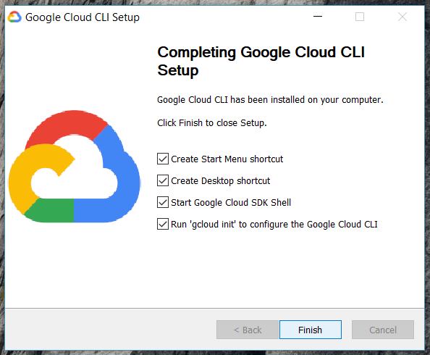

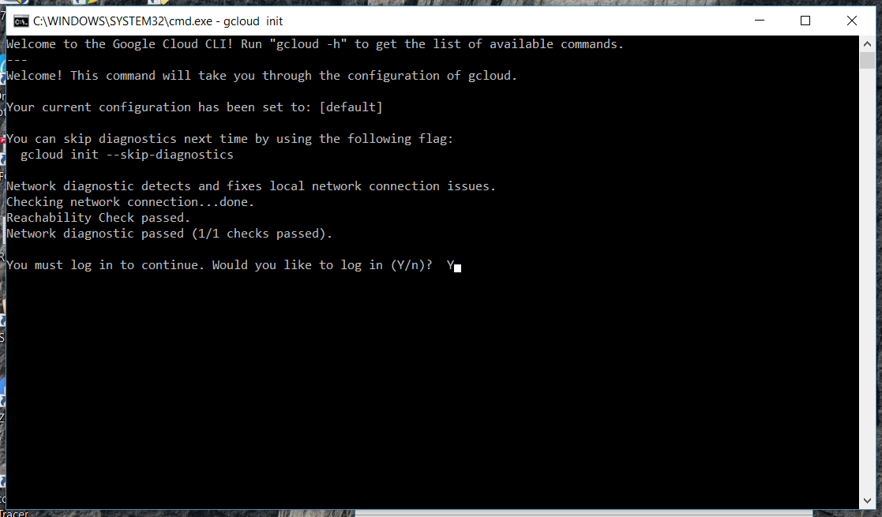

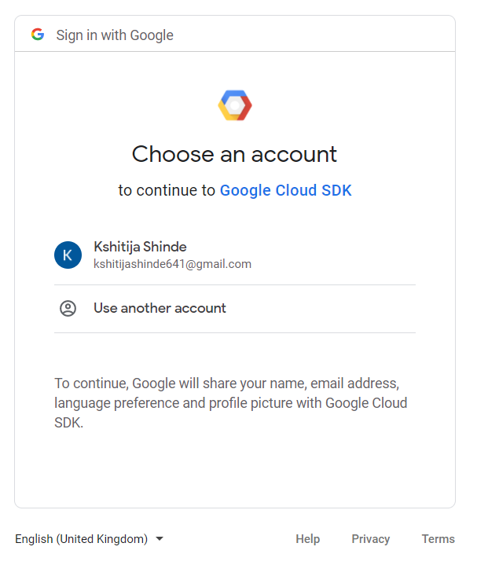

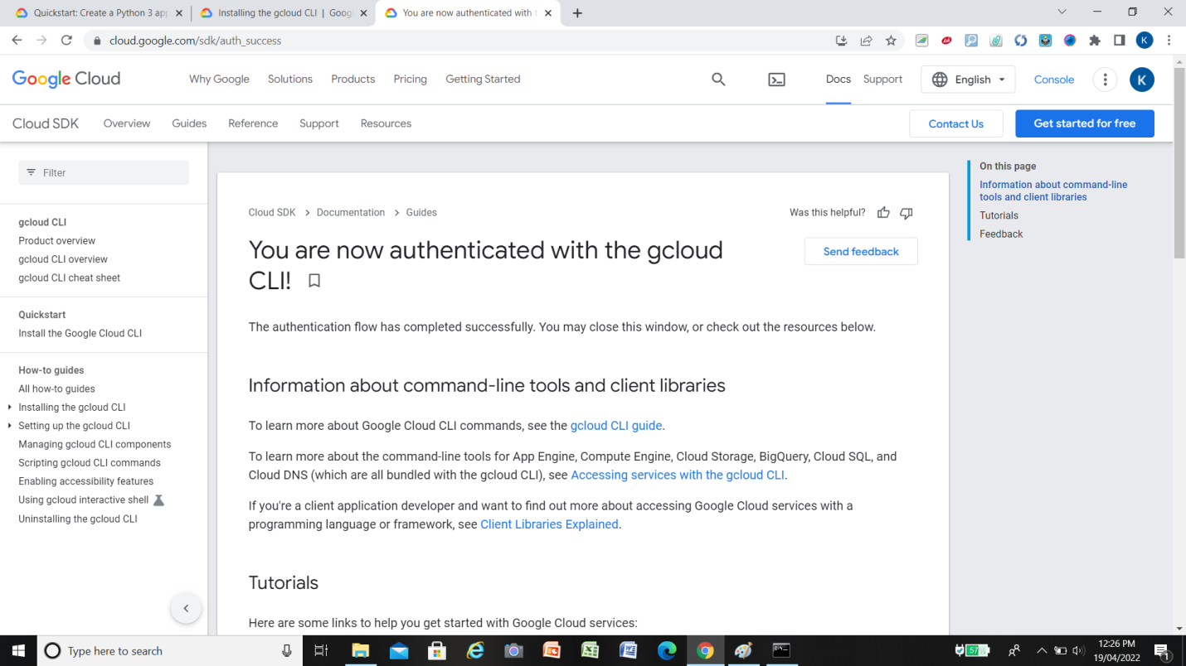

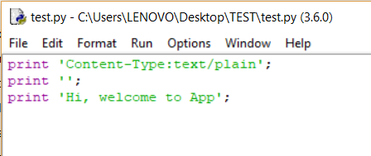

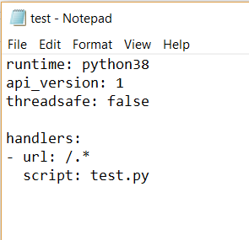

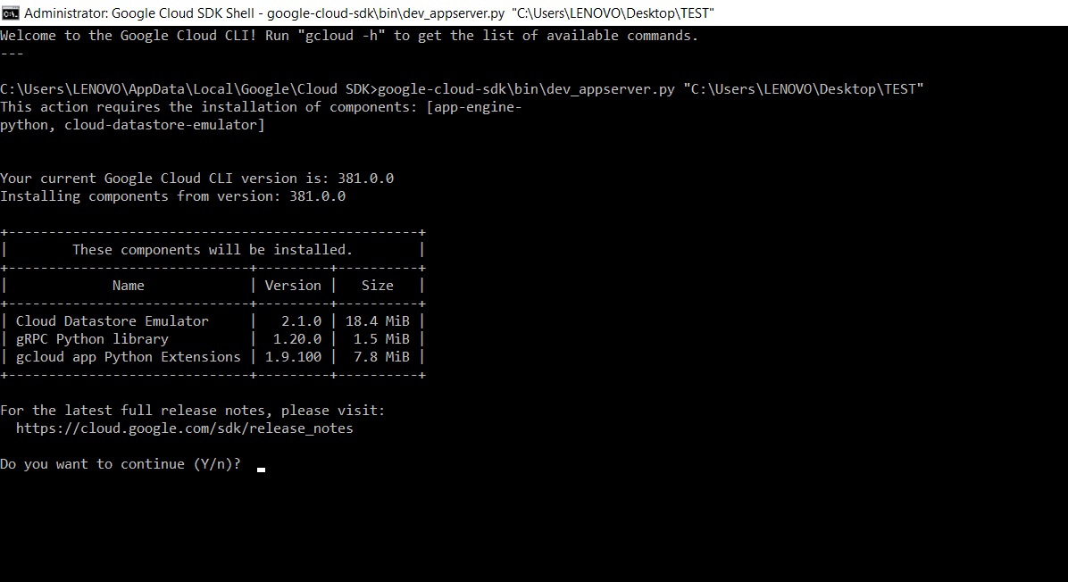

**Title:** Creating an Application in SalesForce.com using Apex programming Language.

**CreateAccount.apxc**

public class CreateAccount {

public String name {get; set;}

public String phoneNumber {get; set;}

public String selectedname {get; set;}

public String websiteURL {get; set;}

public List<Selectoption> lstnamesel {get; set;}

public CreateAccount(ApexPages.StandardController controller) {

lstnamesel = new List<selectoption>();

lstnamesel.add(new selectOption('','- None -'));

lstnamesel.add(new selectOption('IT','IT'));

lstnamesel.add(new selectOption('MECH','MECH'));

lstnamesel.add(new selectOption('CHEM','CHEM'));

lstnamesel.add(new selectOption('PHARMA','PHARMA'));

}

public PageReference createAccount() {

System.debug('teset create');

if(!String.isEmpty(name)) {

Account accountRecord = new Account(Name = name,

Phone = phoneNumber,

Industry = selectedname,

Website = websiteURL);

INSERT accountRecord;

PageReference pg = new PageReference('/'+accountRecord.Id);

pg.setRedirect(true);

return pg;

} else {

ApexPages.addmessage(new ApexPages.message(ApexPages.severity.CONFIRM,'Please enter

Account Name'));

}

return NULL;

}

public PageReference cancelAccount() {

PageReference pg = new PageReference('/'+Schema.SObjectType.Account.getKeyPrefix()+'/o');

return pg;

}

}

**CreateAccount.vfp**

<apex:page standardController="Account" extensions="CreateAccount">

<apex:form id="apexFrom" >

<apex:pageBlock title="Create Account:" id="pageBlockId">

<apex:pageMessages id="showmsg"></apex:pageMessages>

<apex:pageBlockSection columns="2" >

<!--<div class = "requiredInput">

<div class = "requiredBlock"></div>

<apex:inputText value="{!name}" label="Account Name" required="true"/>

</div>-->

<apex:inputText value="{!name}" label="Account Name" required="true"/>

<apex:inputText value="{!phoneNumber}" label="Phone" />

<apex:selectList size="1" value="{!selectedname}" label="Industry">

<apex:selectOptions value="{!lstnamesel}"/>

</apex:selectList>

<apex:inputText value="{!websiteURL}" label="Website" />

</apex:pageBlockSection>

<apex:pageBlockButtons >

<apex:commandButton action="{!createAccount}" value="Save"/>

<apex:commandButton action="{!cancelAccount}" value="Cancel"/>

</apex:pageBlockButtons>

</apex:pageBlock>

<!-- ACTION FUNCTIONS-->

<apex:actionFunction name="createFunction" action="{!createAccount}"/>

<apex:actionFunction name="cancelFunction" action="{!cancelAccount}"/>

</apex:form>

</apex:page>

**Output :**

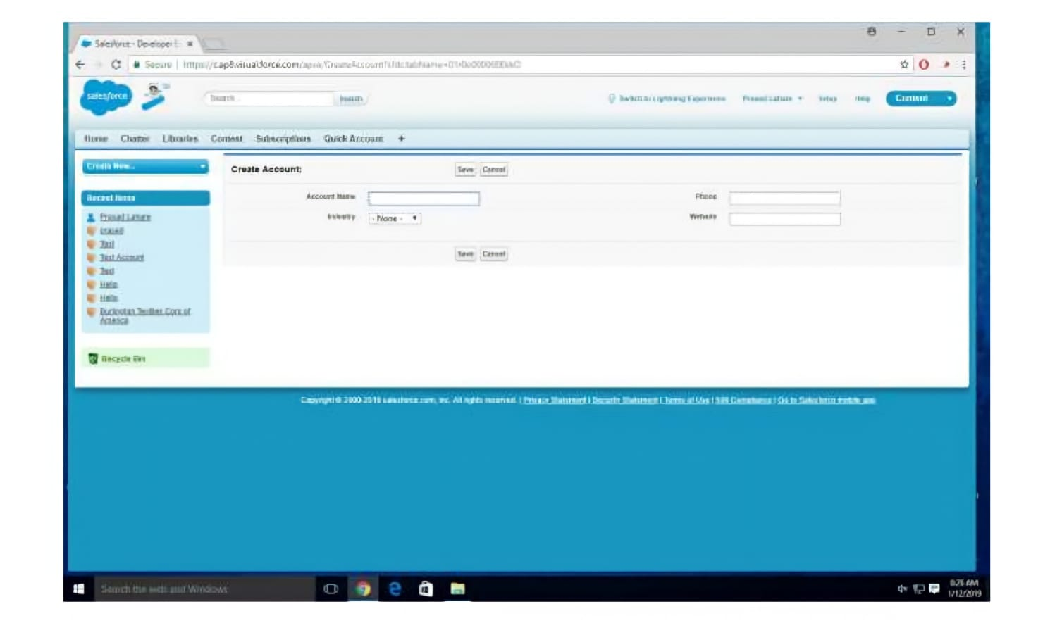

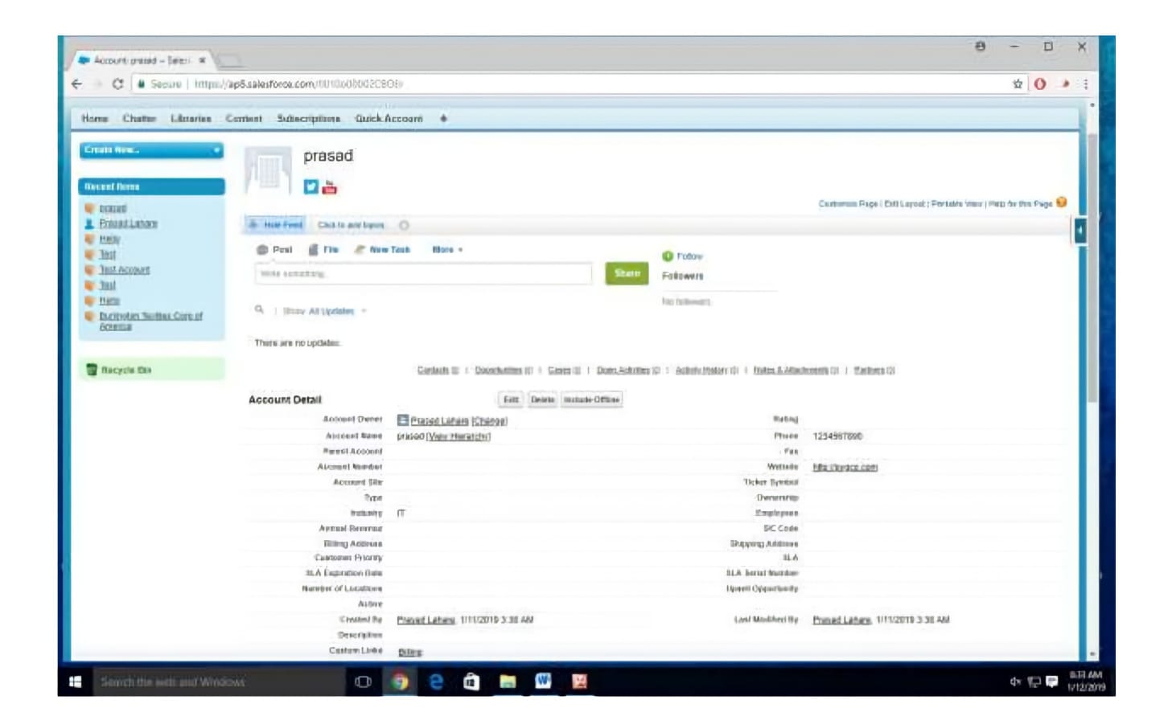

**Assignment No. 4**

**Aim :** Design and develop custom Application (Mini Project) using Salesforce Cloud.

**Soln :**

**OUTPUT :**

**Creating Object :**

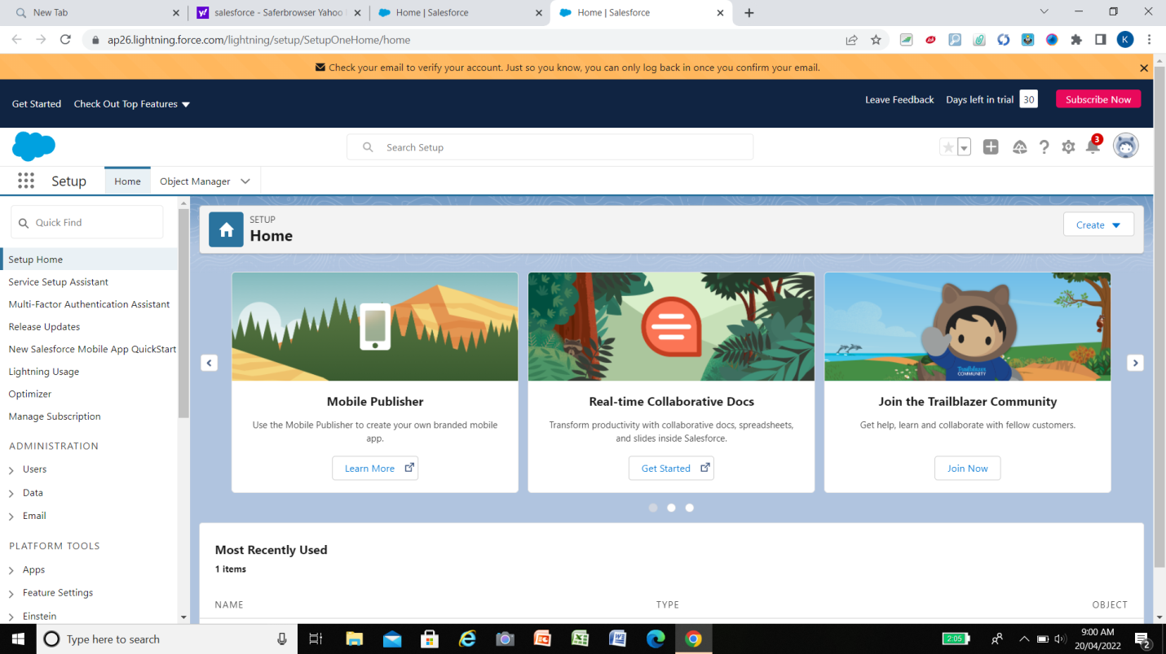

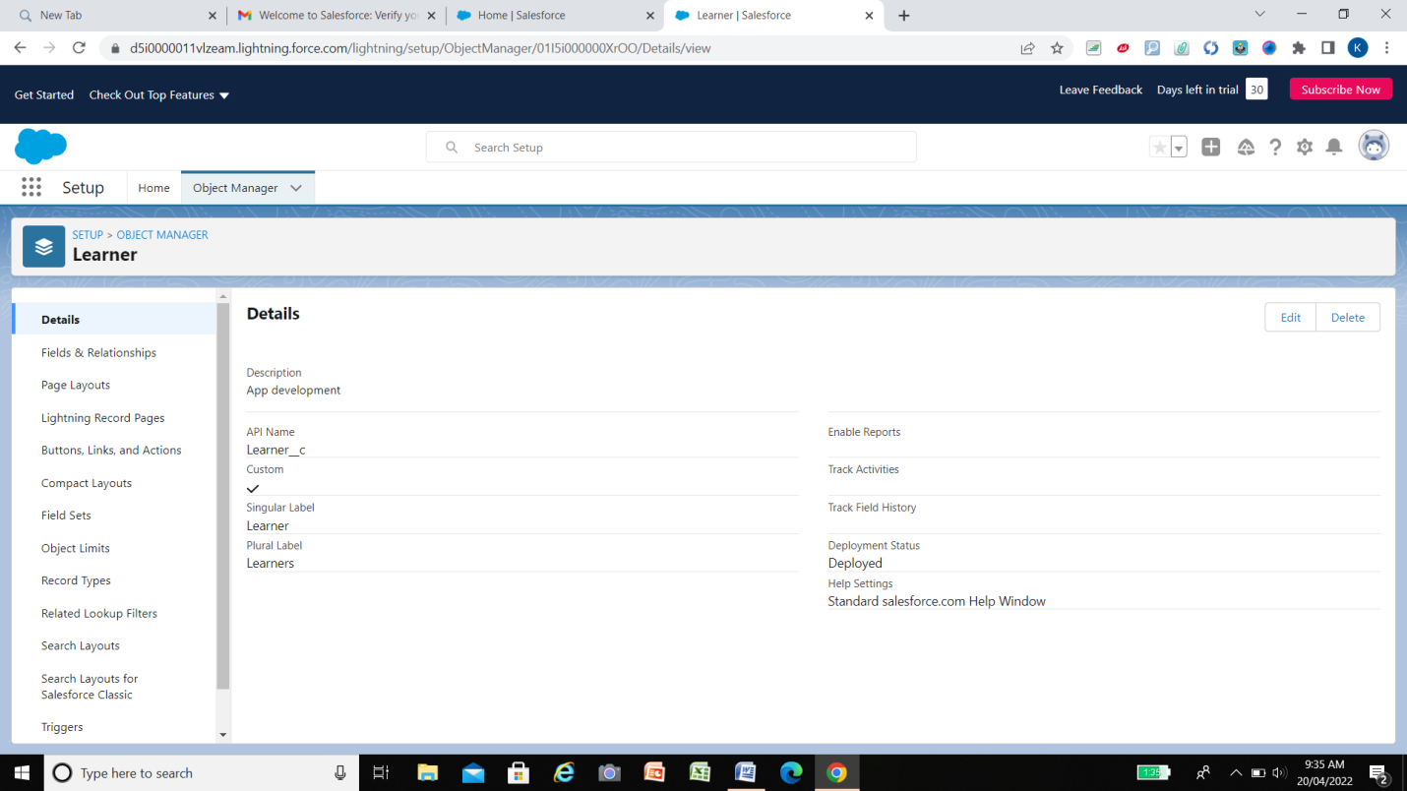

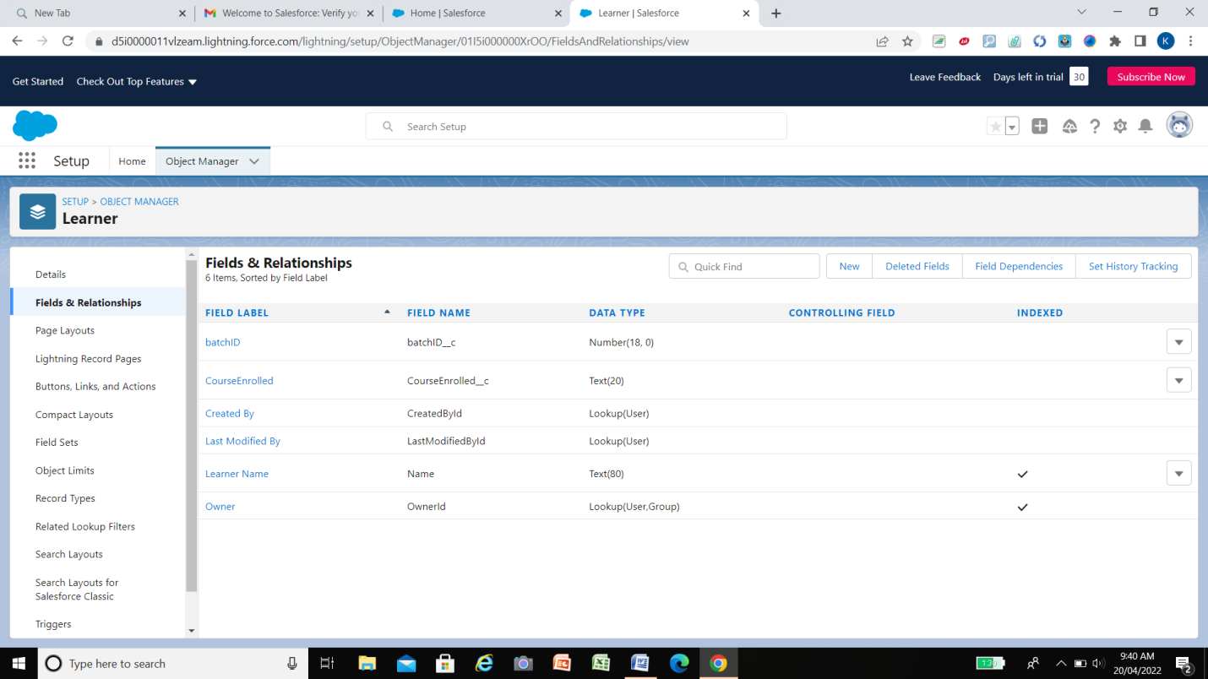

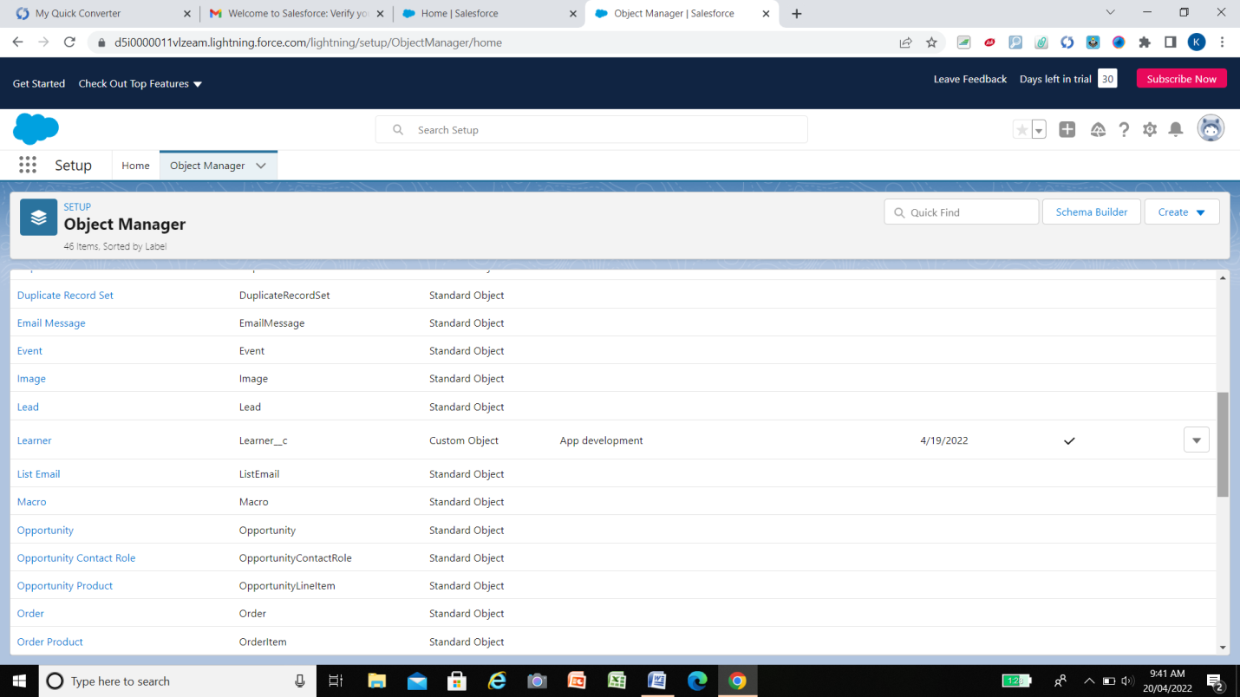

**Developing App :**

